EXPERIMENT-9
Statement:
To integrate Jenkins with Docker on an Amazon Linux system to automate the building and deployment of a Dockerized application using a Jenkins pipeline
Description:
To automate the deployment of a containerized application using Jenkins and Docker. Jenkins is a popular open-source automation server used to implement Continuous Integration/Continuous Deployment (CI/CD) pipelines, while Docker is a platform that allows developers to package applications and their dependencies into containers for consistent deployment across environments.
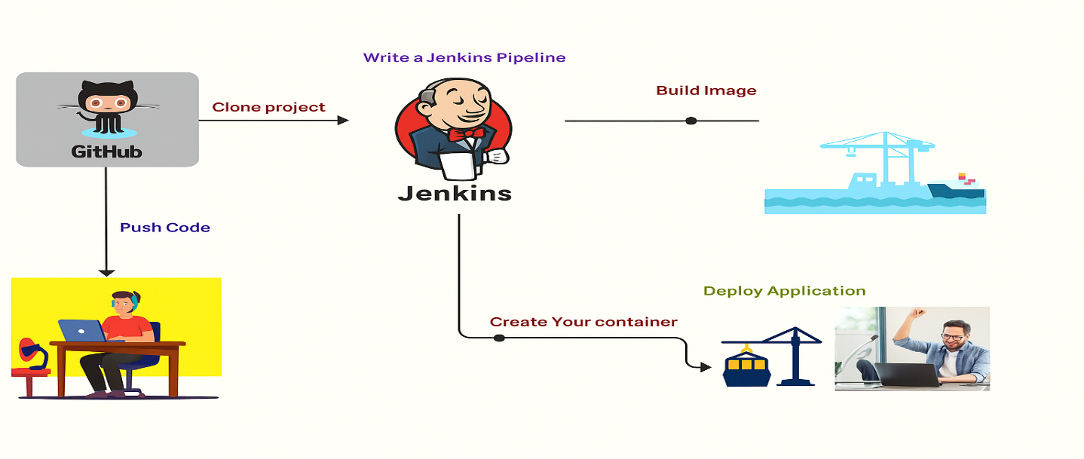
In this integration task, Jenkins is configured to work with Docker on an Amazon Linux server. The process involves setting up both tools, linking them, and creating a pipeline that automatically performs the following steps:
- Fetches Source Code from a GitHub repository containing a Dockerfile and a simple index.html file.
- Builds a Docker Image using the Dockerfile—in this case, an Apache web server serving the custom HTML page.
- Runs a Docker Container from the built image and maps it to port 8181, making the web page accessible via a browser.
Procedure: Jenkins and Docker Integration – Step-by-Step Procedure
Prerequisites
- Amazon Linux (or similar Linux-based server)
- Internet access to install packages and access GitHub
- GitHub repository with a Dockerfile and index.html
Step 1: Update System
- sudo yum update -y
Step 2: Install Java 17 (OpenJDK) via RPM/YUM
- sudo yum install java-17-openjdk java-17-openjdk-devel -y
Step3: Verify the installation
- java -version
Step 4: Add Jenkins Repository
- sudo wget -O /etc/yum.repos.d/jenkins.repo https://pkg.jenkins.io/redhat-stable/jenkins.repo
- sudo rpm --import https://pkg.jenkins.io/redhat-stable/jenkins.io.key
Step 5: Install Jenkins
- sudo yum install jenkins -y
Step 6: Start and Enable Jenkins Service
- sudo systemctl start jenkins
- sudo systemctl enable jenkins
Step 7: Check Jenkins status:
- sudo systemctl status jenkins
Step 8: Retrieve Initial Admin Password
- sudo cat /var/lib/jenkins/secrets/initialAdminPassword
Step 9: Complete Jenkins Setup in Browser
Step 10: Open your browser and go to:
- http://<your-server-ip>:8080
- Paste the initial admin password and click Continue.
- Select Install suggested plugins (recommended).
- Create the admin user account or continue with default.
- Set the Jenkins URL if prompted.
- Click Start using Jenkins
To install Docker in Amazon-Linux
Step 11: Update the installed packages
- sudo yum update -y
Step 12: Install Docker using yum
- sudo yum install docker -y
step 13: Start the Docker service
- sudo service docker start
step 14: Enable Docker to start on boot
- sudo systemctl enable docker
Step 15: Give Jenkins Permission to Use Docker
- usermod -aG docker jenkins
- usermod -aG root jenkins
- sudo chmod 777 /var/run/docker.sock
- sudo systemctl restart docker
step 16: Add your user to the docker group
- sudo usermod -a -G docker ec2-user
step 17: Verify Docker is working
- docker info
Step 18: Prepare Your Application Files
vim index.html
<html>
<head>
<title>Registration</title>
</head>
<body bgcolor="#e0f7fa" text="#004d40">
<marquee bgcolor="#004d40" style="color:#e0f7fa; font-weight:bold;">
Welcome to Krishna Devops :: Learn Here and Lead Anywhere
</marquee>
<center>
<h1>Krishna-Devops Institute</h1>
<p><b>Empowering Careers in DevOps, Cloud, and Full Stack Technologies</b></p>
<form action="#" method="post" bgcolor="#ffffff">
<table bgcolor="#ffffff" border="1" cellpadding="10" cellspacing="0" width="350">
<tr>
<td><label for="name">Full Name:</label></td>
<td><input type="text" id="name" name="name" required></td>
</tr>
<tr>
<td><label for="email">Email Address:</label></td>
<td><input type="email" id="email" name="email" required></td>
</tr>
<tr>
<td><label for="phone">Phone Number:</label></td>
<td><input type="tel" id="phone" name="phone" required></td>
</tr>
<tr>
<td><label for="course">Select Course:</label></td>
<td>
<select id="course" name="course" required>
<option value="">--Select--</option>
<option value="devops">DevOps</option>
<option value="python-fullstack">Python Full Stack</option>
<option value="java-fullstack">Java Full Stack</option>
<option value="aws">AWS</option>
<option value="linux">Linux</option>
</select>
</td>
</tr>
<tr>
<td colspan="2" align="center">
<input type="submit" value="Register" />
</td>
</tr>
</table>
</form>
<h3>Explore Our Courses:</h3>
<a href="https://example.com/devops" target="_blank">DevOps</a> |
<a href="https://example.com/python" target="_blank">Python Full Stack</a> |
<a href="https://example.com/java" target="_blank">Java Full Stack</a> |
<a href="https://example.com/aws" target="_blank">AWS</a> |
<a href="https://example.com/linux" target="_blank">Linux</a>
<p>&copy; 2025 Krishna-Devops. All rights reserved.</p>
</center>
</body>
</html>
Step 19: Create Dockerfile
- vi Dockerfile
FROM ubuntu
RUN apt-get update -y && apt-get install apache2 -y
COPY index.html /var/www/html/
CMD ["/usr/sbin/apachectl", "-D", "FOREGROUND"]
Step 20: Push Code to GitHub
- sudo yum install git -y
- git init .
- git add Dockerfile index.html
- git commit -m "Initial commit"
- git remote add origin https://github.com/<your-username>/<your-repo>.git
- git push origin master
Step 21: Install Docker Plugins in Jenkins
- Open Jenkins Dashboard
- Go to Manage Jenkins → Manage Plugins
- Under the Available tab, search and install:
- Docker plugin
- Docker Pipeline
- Restart Jenkins if prompted
Step 22: Create Jenkins Pipeline
- Go to Dashboard → New Item
- Choose Pipeline, name it: Docker-Pipeline
- Scroll to the Pipeline section and write the pipeline script
pipeline {
agent any
stages {
stage('Clone repository') {
steps {
git 'https://github.com/Milky19/docker-jenkins.git'
}
}
stage('Build Docker Image') {
steps {
sh 'docker build -t mywebsite .'
}
}
stage('Run Docker Container') {
steps {
sh 'docker run -d -p 8181:80 --name myapp mywebsite'
}
}
}
}
- Click Save, then click Build Now to execute the pipeline
Step 23: Verify the Application
- Open your browser and go to
- http://<your-server-ip>:8181
